Use of Main W8DYY Station
- Access shack using combination code open door. Turn on lights alarm panel will be beeping. Immediately enter access code into alarm panel, panel will stoop beeping. Both codes are on your membership card.
- Pring your name and call time and reason for accessing the shack on the member’s log.
- Assess general condition of the shack, anything obviously wrong missing or damaged equipment. Report any out of the ordinary conditions to one of the executive board members or the equipment manager.
- This procedure assumes that the rig to be used is the Icom IC-7600 with the patch panel, LDG 600 PRO II and the Mosley beam with rotor. Note Drake L4B is not to be used with the IC-7600.
- Plug in the following items to 120 Volts AC: Astron R3 35M power supply, Hy-gain Antenna Rotor control. Turn on the power switches on the Astron and plug the rotor control cable into the Hy-gain rotor control unit and plug it into 120 VAC.
- Turn on the power on the IC-7600 by pressing and holding the power switch. Turn on the power to the Hy-gain rotor control by pressing its power switch.
- Turn up the volume on the Icom IC-7600, signals or at least some static should be heard. If not check the connection from the patch panel to the 7600. DO NOT PROCEED WITH TUNING UP UNTILL SIGNALS CAN BE HEARD. If in doubt call for help.
- On the IC-7600 select Band and frequency to be used. Find a clear frequency close to the desired operating frequency and key the IC-7600. The LDG 600 PRO II will automatically tune the output of the IC-7600 to the Mosley.
- Ensure that the VSWR on the IC-7600 is at a minimum level less than 1.5 to 1 the station is now ready for operation as a barefoot 100-watt station.
- Simply set the mode to the mode desired and increase the power setting on the IC-7600 up to 100 Watts. Rotate the Mosley to the desired direction.
- Be sure to use the W8DYY call when using the club station and log any contacts in station log book.
Using IC-7600 with either linear amp is not recommended currently.
FT-8 / FT-4 Digital Sation Operation
- This procedure assumes that the rig to be used is the Kenwood TS-480SAT with the patch panel, LDG 600 PRO II and the Mosley beam with rotor. Note Drake L4B is not to be used with the TS-480SAT.
- Plug in the following items to 120 Volts AC: Astron SS-25M power supply, Hy-gain Antenna Rotor control , the digital station computer and its monitors. Turn on the power switches on the Astron and plug the rotor control cable into the Hy-gain rotor control unit and plug it into 120 VAC.
- Connect the Kenwood connection on the patch panel to the Mosely.
- Turn on the Rotor Control, the Astron power supply, the digital station computer and monitors, finally the TS-480SAT.
- Listen for signal or at least static being received. If no signal is obvious recheck the connections, if still no signal stop and ask for help.
- Once it is determined that signals are being received start the WSJTX program then the N3FJP contact logging software. Additionally, any other tracking software.
- Check the RF output setting of the TS-480SAT is more than 10 watts but less than 30 watts.
- Using the menu in the WSJTX select a band between 40 and 10 meters and the proper section for the version of FT you are running.
- Using the tune button in the WSJTX software transmits a 30 to 60 second burst so that the LDG 600 PRO II will match the TS-480SAT to the antenna. Verify that the SWR is < 1.5 to 1. If not repeat this step. If after the third, try the SWR is still not in spec stop and ask for help.
- If all is in order proceed then make contacts being sure to log them in to the software. Rotate the antenna as needed. Retune when changing bands.
- When done, be sure to save and close the logging program. Shut down the WSJTX software. Shut down the computer then TS-480SAT the Astron power supply and finally rotate the antenna back to a west direction turn off the Hy-gain controller and unplug the control cable for the back of it.
- Lastly disconnect the Kenwood from the Mosley the connect the Mosley to GROUND.

DRAKE TR-7 and L4B
- These are older and somewhat fragile units and require more set up than practical to cover in the procedure. Contact senior club members for assistance.

Shutting Down the Station

- Finish Logbook entries if needed.
- Verify power is off and disconnected for each station and all associated equipment used.
- Verify beam facing west. If not reconnect HY-gain and properly position, then disconnect.
- Verify that both antennas are connected to a “GROUND” port.

Securing the Shack.
- Verify that a equipment used has been properly turned off and secured.
- Verify all windows and doors except the north entrance door are shut and locked, this includes the sliding door in the middle of the shack. Verify that the hasp is in place on that door.
- Fill out the members log with you exit time.
- Turn off lights and enter security code. Exit and lock the deadbolt on the north exit door. Remain at the door listing for an audible buzz indicating that the alarm is set.

Patch Panel Stowed connection
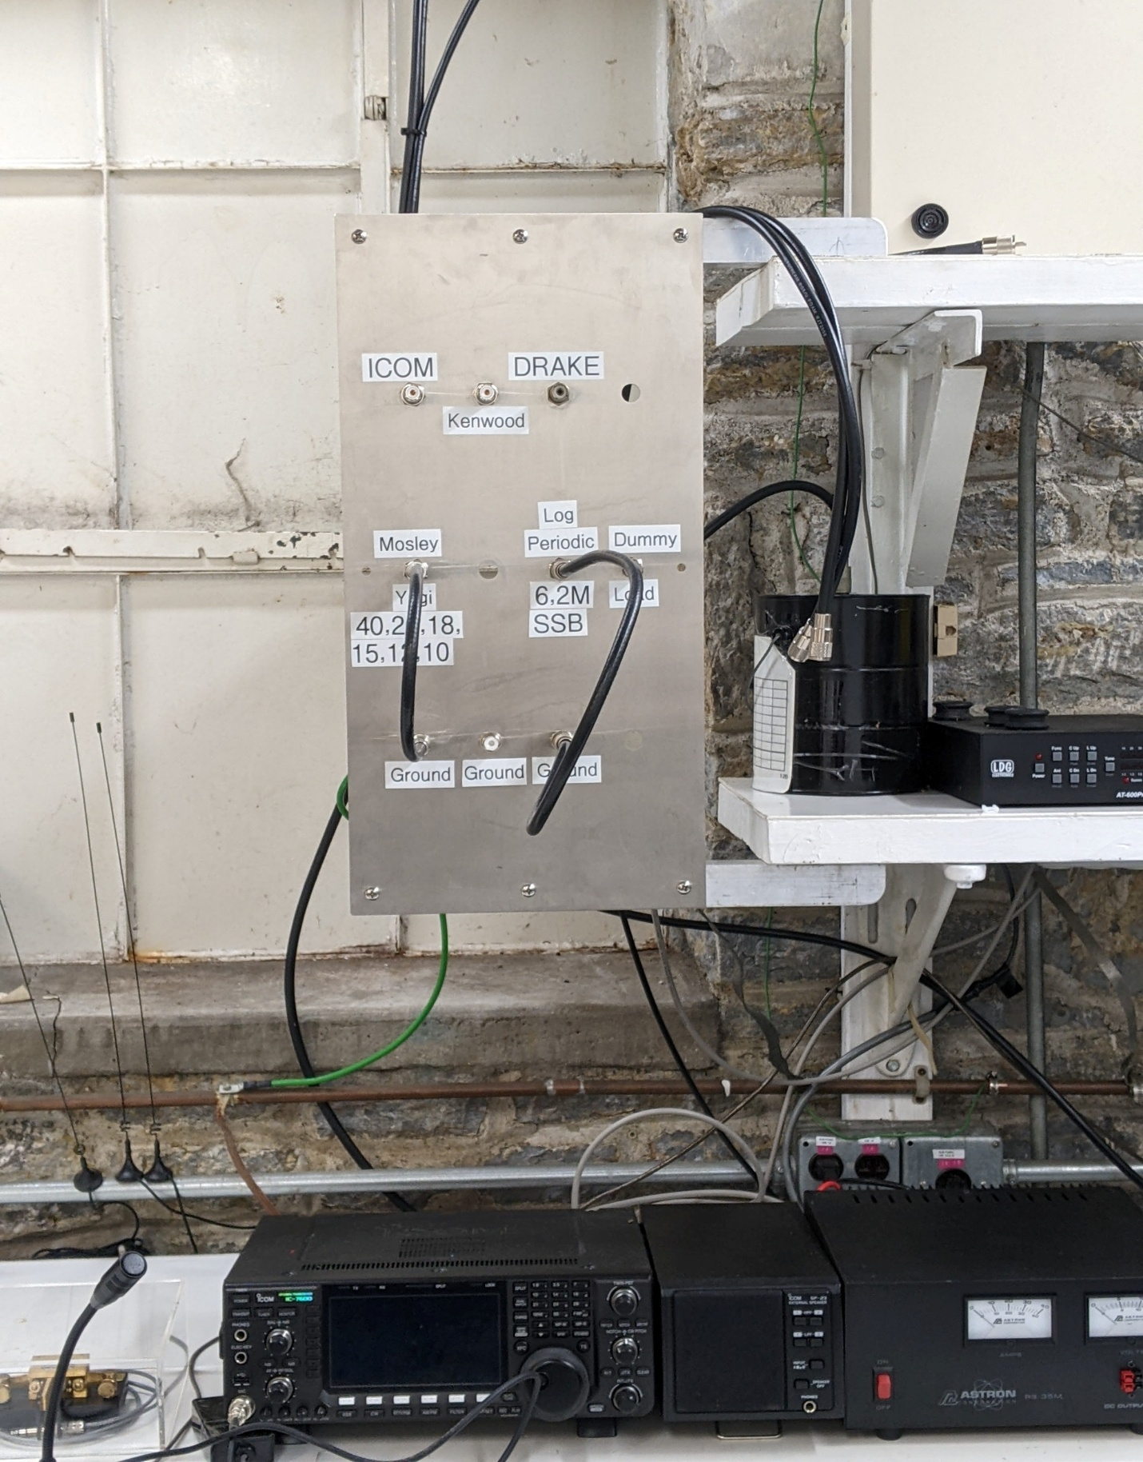
Patch Panel Kenwood to Mosley Connection
